Pls contact us :35007117@ qq.com
----------------------------------------------------------
reed switch module
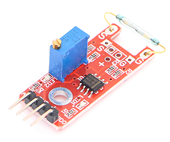

reed switch module can connect UNO R3 PIN13, make magnetic test.
Pin 13’s LED，use reed switch module connect Pin 3. When hall module test there is magnetic, led can be bright.

例程源代码：
int Led=13;//定义LED 接口
int buttonpin=3; //定义磁环传感器接口
int val;//定义数字变量val
void setup()
{
pinMode(Led,OUTPUT);//定义LED 为输出接口
pinMode(buttonpin,INPUT);//定义磁环传感器为输出接口
}
void loop()
{
val=digitalRead(buttonpin);//将数字接口3的值读取赋给val
if(val==HIGH)//当磁环传感器检测有信号时，LED 闪烁
{
digitalWrite(Led,HIGH);
}
else
{
digitalWrite(Led,LOW);
}
}

